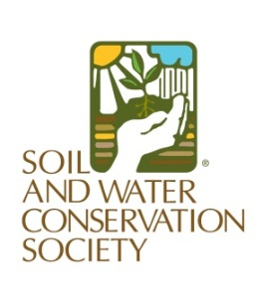
My Sediments Submission Instructions
Oregon Chapter SWCS quarterly newsletter

Submit articles, questions or comments to:
Teresa Matteson
Tmatt0@rtdata.com
541-840-3616

Submission Schedule:
Deadline for articles | Distribution date
February 15 | March 1
May 15 | June 1
August 15 | September 1 – announce annual meeting
November 15 | December 1 – before end of year craziness

Please include the following information/content.

Title:
Author:
Author’s contact information:

Content type: Information Article Report
Time sensitive material (circle)? No Yes: deadline date:
Target Word length: 75 to 200 words

Graphics– for each article include at least one and up to three graphics.
- Photos: include caption and photographer credit (Copyright © YEAR[NAME] ).
- Graph/Chart: brief description of data and readable units.

Thanks for supporting the Oregon Chapter SWCS educational network!

